Training School “Experimental Models in Adhesion GPCR Research”
October 5-6th 2020

We are pleased to announce a virtual training school “Experimental Models in Adhesion GPCR Research” within COST action CA18240 “ADHEsion GPCR Network: Research and Implementation Set the path for future Exploration” (Adher‘n Rise). The school will be broadcasted via ClickMeeting platform.
The training school is designed for PhD students and postdocs interested in aGPCR research. The trainees will have a chance to learn about application of mammalian cell lines, primary human brain immune cells, worms and zebrafish as model systems in functional studies of aGPCRs. Furthermore, they will be offered training in state-of-the-art and traditional methodology associated with these models, such as targeted genome editing, small molecule screens, live imaging, and generation of antibodies and recombinant proteins.
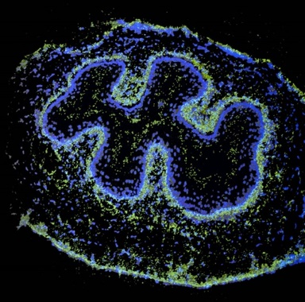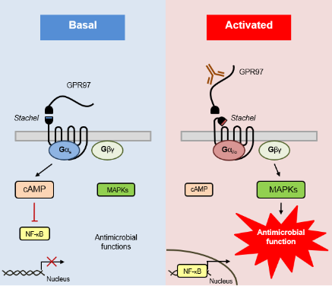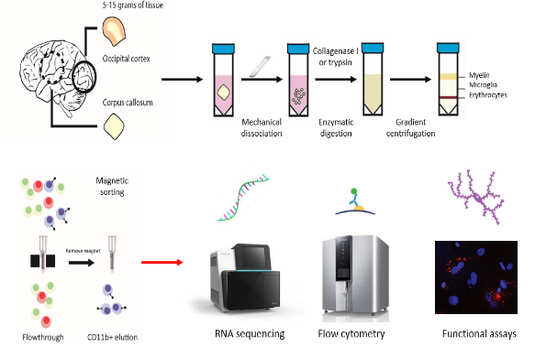
Trainers:
- Joerg Hamann (Amsterdam University Medical Centers, Amsterdam, Netherlands)
- Samantha Hughes (Hogeschool van Arnhem en Nijmegen, Nijmegen, Netherlands)
- Hsi-Hsien Lin (Graduate Institute of Basic Medical Sciences, Chang-Gung University College of Medicine, Tainan, Taiwan)
- Kelly Monk (Vollum Institute, Oregon Health & Science University, Portland, USA)
Organizer: Katarina Trajkovic (Mediterranean Institute for Life Sciences – MedILS, Split, Croatia)

Registration deadline: 20-Sept-2020

Preliminary schedule

Day 1 (October 5th)
Morning session – Hsi-Hsien Lin
9:00 – 10:30 Lecture: “In vitro functional studies of aGPCRs in immune system and in cancer”
10:45 – 11:30 Lab videos: Generation of monoclonal antibodies and human recombinant proteins
11:45 – 12:15 Chat room with participants

Afternoon session – Kelly Monk
15:00 – 16:30 Lecture: “Zebrafish as a model system in studying physiological functions of adhesion GPCRs”
16:45 – 17:15 Lab videos: How to use Zebrafish to study adhesion GPCRs
17:15 – 17:45 Chat room with participants

Day 2 (October 6th)
Morning session – Joerg Hamann
10:00 – 11:30 Lecture: “Adhesion GPCRs in immunity – from blood to brain”
11:45 – 12:30 Lab videos (TBA)
12:45 – 13:15 Chat room with participants

Afternoon session – Samantha Hughes
15:00 – 16:30 Lecture: “Using C. elegans to elucidate the function of aGPCRs“
16:45 – 17:15 Lab videos: How to handle C. elegans and explore genetic mutants
17:15 – 17:45 Chat room with participants

REGISTRATION is free of charge and unlimited, with the entire content of the school accessible to all registered trainees. However, active participation in the chat room will be reserved for a limited number of 20 (preferably junior) trainees. Engagement in the chat room will be granted on a first-come-first-served base during the registration process. Only participants of the chat room will be entitled to a training school certificate.

Contact:
Katarina Trajkovic
E-mail: katarina.trajkovic@medils.hr
Tel: +385 21 555 604

Registration:
https://forms.gle/MsoKrvGHwZTUk6nt6

